September 14, 2022

September 16, 2022

Note: Have a milestone and issue done by Sunday 7pm

Aggregates – Student notes LINQ - More Method Syntax

* Create a milestone and create issues for exercise.
* Create 6 individual issues for each individual question in a Milestone

Commit #n …………….

Close n

September 19, 2022



Grouping: <https://dmit-2018.github.io/demos/eRestaurant/linq/LinqPad/expressions.html>

Big pile of data (b p d) can be groups based on field. Therefore, you can create multiple group of data for different field(s)

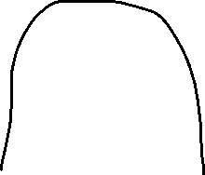

Question 4 & 6 grouping

September 21, 2022

Conversion: <https://dmit-2018.github.io/demos/eRestaurant/linq/extensions.html#conversions>

List: data is in memory. No conversion from sql

Convert to strongly typed data type

Firstor deault: <https://dmit-2018.github.io/demos/eRestaurant/linq/extensions.html#selection-filters>

First will give you first record….what if there is no records (and if you do if else for comparison) then it throws an error….default will give null ( default of object is null) then we can compare null

September 23, 2022

Go over Question 5 (need to use multi query --- reference to inclass example)

You can solve a problem with two queries. One query to get vital information and then run second to get to answer

Rest of class for assignment

September 26, 2022

Any or All examples

--🡪 DOTNETTUTORIALs <https://dotnettutorials.net/lesson/introduction-to-linq/>

Msft doc:

<https://learn.microsoft.com/en-us/dotnet/api/system.linq.enumerable.except?view=net-7.0>

except is useful for simple dataset like numbers. Any or All works for complex dataset like songs.

Transactions

A transaction changes the contents of a Table/Records

DML commands Insert, Update and Delete

Single Change in a record either worked or not

Multiple changes in a record then need to determine commit and rollback (1 commit for whole change but many rollbacks)

How many rollback executes? One as after one fails, it rollbacks

When we get into Business Logic Service Method

Method signature

Throw exception



Throw exception



Throw exception



.SaveChange()



October 3, 2022

Went over exercise solution

October 7, 2022

Markdown tutorial <https://www.markdowntutorial.com/>

Documentation for exercise 02

* [ ] Create Data Models

Notes on github

October 12, 2022

Worked on documentation on github

Create a similar connection from existing EF

October 14. 2022

At Entwistle, follow in class demonstration in folder “issues” and “Testing Design in Linqpad”

October 17, 2022

Line 250 in oct 14 file can be put in loop to go through every track. Right now it is for only one record.

October 21, 2022

Exercise due on 28th oct based on a tutorial (follow email instruction 30 min exercise)

Exercise of design document is pictures on phone

October 24, 2022

Assessment 3 & 4 will be based on exercise 3 – trx method – Based on FSIS database

Move methods uploaded on git

Exercise 3: will have to do extra query to bring data from database in addition to data models in your trx method.

October 26, 2022

Setup class library –

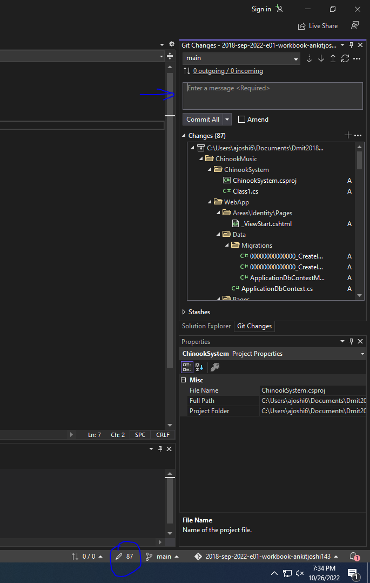

* Reverse Engineering document

October 28, 2022

Talked about deliverable (attached picture)

Next week project specification will be released. Please read over. Also, team repository will be released following week. No milestone or issue due. We will talk about it when we go over specification together. Monday

Install-Package Microsoft.EntityFrameworkCore.Tools

Scaffold-DbContext 'Data Source=.\SQLEXPRESS;Initial Catalog=Chinook;Integrated Security=True' Microsoft.EntityFrameworkCore.SqlServer -o Entities

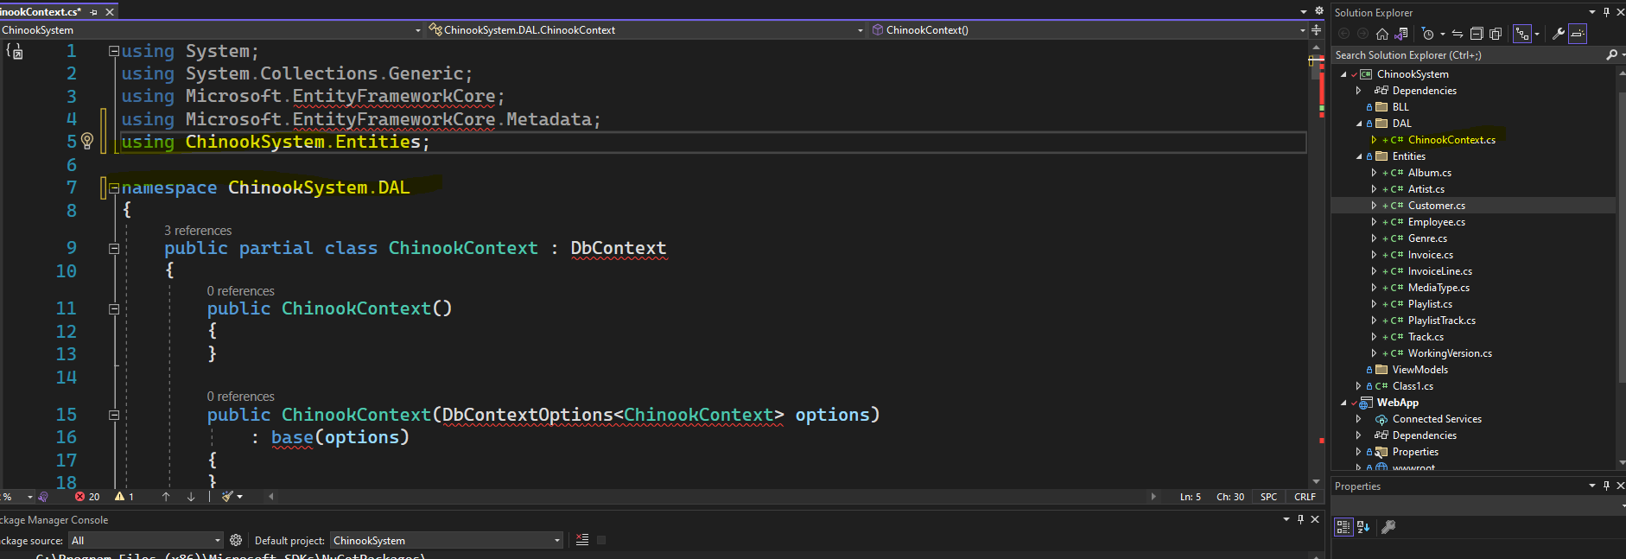

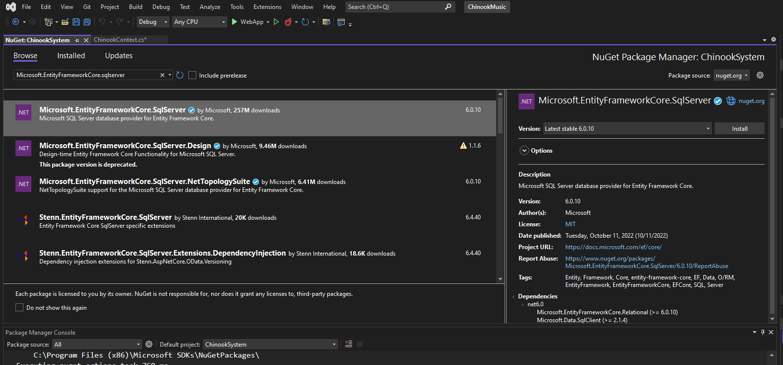

Should have following two packages

Not 6.0.10 need to update

Rebuild solution

Should have following file in DAL

Add class now

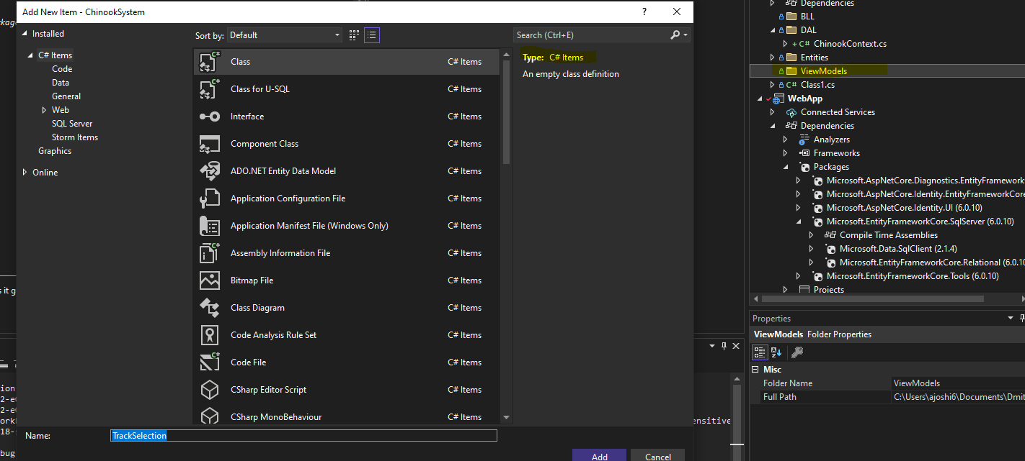

Add other model class PlaylistTrackInfo, and PlaylistTrackTRX

Now, we should have query and command model.

Make context and entities class internal if its public

Bootstrap is long so personally he gonna delete the library

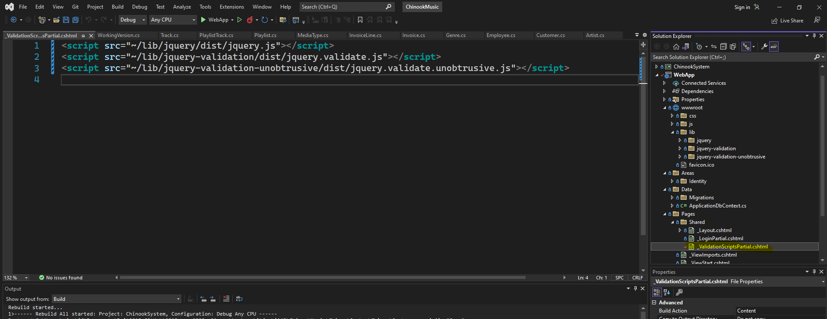

Modify the highlighted file

November 2, 2022

* Accept the project repo
* Resume on visual coding